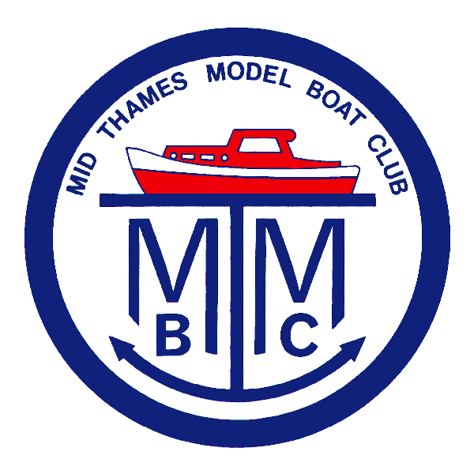
2018

Thank you for your interest in our club.

As you have probably gathered from our website, we are a small but growing club, (just over fifty active members at present), operating in the very pleasant surrounds of Beale Park, near Pangbourne.

Our members have varies interests - there is a sailing group who are able to operate all year round on the big outer lake, a fast electrics section who operate on both lakes, although we do have to restrict the very fast boats to the outer lake. They join forces with Electra, a national fast electrics body on some occasions. On the inner lake, we race Club 500s, which is a national class, and also F600s, which are a slightly faster “one design”, developed within our club.

The inner lake hosts our tug enthusiasts, where regular towing competitions take place, using a variety of barges, and even an eight foot model tanker to tow. Many of the models have propulsion systems accurately copying modern full size practices, making these models extremely manoeuvrable.

Various steering and time trials are run throughout the season for our many “scale” enthusiasts. Their models cover the whole spectrum - warships, lifeboats, merchant ships, sailing barges, and even the odd hovercraft and airboat.

We co-host an annual model boat show, which draws clubs and exhibitors from all over the south. It is always very well attended, and features many demonstrations. Etc. A copy article from “Model Boats” is attached, and also a photo from that magazine. You can learn some more about us by reading the latest edition of our quarterly mamgazine “VoicePipe” which is on the website.

We have a dedicated area by the inner lake, where we have a clubhouse with a battery charging system installed. This is available to members whenever the park is open. Many of our members are experts in their own fields, so friendly advice and help is always on hand if needed.

During the summer, we have weekly social meetings, where any model is welcome, or just come and sit in our compound, relax, enjoy the view and have a cup of tea and a chat. In the winter months, when the park is closed, we have four meetings in Tidmarsh Village Hall, which are mainly social, but include bring & buy models sales, and our AGM.

We have a small but growing junior section, (often youngsters out to beat grandad or dad in a race!), and we run a small fleet of “have-a-go” boats for newcomers of any age.

Last, but by far from least, we have some very active lady members, and they would be delighted to welcome some new faces.

The only boats we cannot allow within the club are anything IC powered. The park is after all dedicated to wildlife. Steam powered boats are very welcome - we do have a few enthusiasts for these models in the club, and would be delighted to swell their ranks.

I hope this letter has given you a feel for our club, but if you have any queries, please come along to the park, aor feel free to contact me for a chat.

Roger Strudwicke, Membership Secretary Mid-Thames Model Boat Club.

